**RESUMEAR: A WEB-BASED RESUME GENERATOR WITH AUGMENTED REALITY FEATURES**

**MARY CHEW JIA YI**

**A project report submitted in partial**

**fulfilment of the requirements for the award of**

**Bachelor of Software Engineering with Honours**

**University Malaysia of Computer Science and Engineering (UNIMY)**

**May 2019**

The copyright of this thesis belongs to the author under the terms of the copyright Act 1987 as qualified by the Intellectual Property Policy of University Malaysia of Computer Science and Engineering (UNIMY). Due acknowledgement shall always be made of the use of any material contained in, or derived from, this thesis.

© 2019, Name of Author. All rights reserved.

DECLARATION

I hereby declare that this project report is based on my original work except for citations and quotations which have been duly acknowledged. I also declare that it has not been previously and concurrently submitted for any other degree or award at University Malaysia of Computer Science and Engineering (UNIMY) or other institutions.

|  |  |  |
| --- | --- | --- |
| Signature | : |  |
| Name | : |  |
| ID No. | : |  |
| Date | : |  |

APPROVAL FOR SUBMISSION

I certify that this project report entitled **“TITLE TO BE THE SAME AS FRONT COVER, CAPITAL LETTER, BOLD”** was prepared by **STUDENT’S NAME** has met the required standard for submission in partial fulfilment of the requirements for the award of Bachelor of XXXXX at University Malaysia of Computer Science and Engineering (UNIMY).

Approved by,

|  |  |  |
| --- | --- | --- |
| Signature | : |  |
| Supervisor | : |  |
| Date | : |  |

Specially dedicated to

my beloved grandmother, mother and father

(this dedication page is optional)

ACKNOWLEDGEMENTS

I would like to thank everyone who had contributed to the successful completion of this project. I would like to express my gratitude to my research supervisor, Dr. XXXXX for his invaluable advice, guidance and his enormous patience throughout the development of the research.

In addition, I would also like to express my gratitude to my loving parent and friends who had helped and given me encouragement......

(This acknowledgements page is optional)......

**PROJECT TITLE IN CAPITAL LETTER**

**TITLE TO BE THE SAME AS FRONT COVER**

ABSTRACT

Many relief scenarios involve the discharge of a two-phase fluid mixture, and the proper method for sizing the relief valve for these conditions is the subject of considerable discussion. Sizing a valve is based on the flow through an isentropic nozzle, the pressure–density relation for the fluid properties, and a discharge coefficient (*Kd*) to match the calculated mass flux to that measured for the flow of air or water in the actual valve. For single-phase flow, this is straightforward, since the fluid properties are simple and measured values of *Kd* are available. For two-phase flow, the density–pressure relation is complex and no values of *Kd* are available, so a variety of ‘‘models’’ have been proposed in the literature to address this problem. Since the various models produce various results, the appropriate value of *Kd* required to match the model to the actual valve will depend on the model. This paper utilizes a simple, rigorous method for sizing relief valves for two-phase flow that utilizes the fluid properties directly and hence does not require a ‘‘model’’ for these properties. It is shown how this method can be applied to two-phase frozen or flashing (equilibrium or non-equilibrium) nozzle flows, and how the available values for *Kd* for single-phase flow can be used directly with this method, depending on the critical state of flow in the nozzle, to accurately predict two-phase flow in any valve. The calculations are compared with data from the literature for frozen air/water and flashing steam/water flows in actual safety relief valves.

TABLE OF CONTENTS

DECLARATION ii

APPROVAL FOR SUBMISSION iii

ACKNOWLEDGEMENTS v

ABSTRACT vi

TABLE OF CONTENTS vii

LIST OF TABLES ix

LIST OF FIGURES x

LIST OF SYMBOLS / ABBREVIATIONS xi

LIST OF APPENDICES xii

**CHAPTER TITLE PAGE**

1 INTRODUCTION 13

1.1 Background 13

1.2 Problem Statement 13

1.3 Aim and Objectives 14

1.4 Scope 15

1.5 Significance of the Project/Research 15

1.6 Organization of Thesis 15

2 LITERATURE REVIEW 16

2.1 Subsection Title 1 16

2.2 Subsection Title 2 16

2.3 Subsection Title 3 17

2.3.1 Sub-subsection Title 1 17

2.3.2 Sub-subsection Title 2 17

2.3.3 Sub-subsection Title 3 18

2.4 Subsection Title 4 18

3 METHODOLOGY 20

3.1 Subsection Title 1 20

3.2 Subsection Title 2 20

3.3 Sub-subsection Title 1 21

3.3.1 Sub-sub-subsection Title 1 21

4 IMPLEMENTATION OF DESIGN 22

4.1 Subsection Title 1 22

4.2 Subsection Title 2 22

4.3 Sub-subsection Title 1 23

4.3.1 Sub-sub-subsection Title 1 23

5 CONCLUSION 24

5.1 Subsection Title 1 24

5.2 Subsection Title 2 24

5.3 Sub-subsection Title 1 25

5.3.1 Sub-sub-subsection Title 1 25

REFERENCES 26

APPENDICES 27

LIST OF TABLES

|  |  |  |
| --- | --- | --- |
| **TABLE** | **TITLE** | **PAGE** |
| 2.1 | Processing Time (in hours) of Bread for Different Production Line in ABC Company | 4 |
| 2.2 | Processing Time for Different Production Line | 5 |
| 3.1 | Processing Time (in hours) of Bread for Different Production Line | 8 |
| 4.1 | Processing Time (in hours) of Bread for Different Production Line | 10 |

LIST OF FIGURES

|  |  |  |
| --- | --- | --- |
| **FIGURE** | **TITLE** | **PAGE** |
| 2.1 | University Malaysia of Computer Science and Engineering Logo | 6 |
| 3.1 | Reflection from Smooth Surface | 8 |
| 4.1 | UniMy Logo | 10 |

LIST OF SYMBOLS / ABBREVIATIONS

*cp* specific heat capacity, J/(kg⋅K)

*h* height, m

*Kd* discharge coefficient

*M* mass flow rate, kg/s

*P* pressure, kPa

*Pb* back pressure, kPa

*R* mass flow rate ratio

*T* temperature, K

*v* specific volume, m3

*α* homogeneous void fraction

*η* pressure ratio

*ρ* density, kg/m3

*ω* compressible flow parameter

ID inner diameter, m

MAP maximum allowable pressure, kPa

MAWP maximum allowable working pressure, kPa

OD outer diameter, m

RV relief valve

LIST OF APPENDICES

|  |  |  |
| --- | --- | --- |
| **APPENDIX** | **TITLE** | **PAGE** |
| A | Graphs | 14 |
| B | Computer Programme Listing | 15 |

## INTRODUCTION

### Background

A resume, or résumé is a document of several pages about a job applicant’s past employment history, education (Resume, n.d.), as well as accomplishments. It often supplies an employment objective as a summary of skills, knowledge, potential contributions, voluntary work, certifications and also relevant coursework. It is useful for the job applicants to apply for posted jobs of any fields when they come across the job opening (Heathfield, 2018).

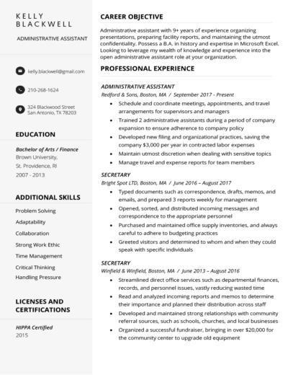

Figure 1.1 A typical resume

The importance of a resume is that job applicants can use it as a marketing tool to impress an employer because it outlines one’s background, skills and education that the employer will be able to see how their individual experiences can contribute to a company’s success (Resume, n.d.). However, when it comes to resume screening, an employer or a recruiter takes only 8-10 seconds or even less on average to screen their resumes before considering them to be shortlisted for pre-screen interviews. Hence, it means that to make a first impression to the employer, a well-written professional resume is required (Roo, 2015).

Augmented Reality, which is abbreviated as AR, is the technology that expands our physical world by adding layers of digital information onto it. Such digital information of any forms like sounds, videos and graphics. Another definition of AR is that a view of the physical real-world environment with superimposed computer-generated images that changes the perception of reality. AR is widely used in most fields like education, tourism, furniture, healthcare, manufacturing and the like (What is Augmented Reality (AR) and How does it work, n.d.). Examples of the popular AR applications are Pokémon Go, Google SkyMap and IKEA (Bonsor & Chandler, n.d.).

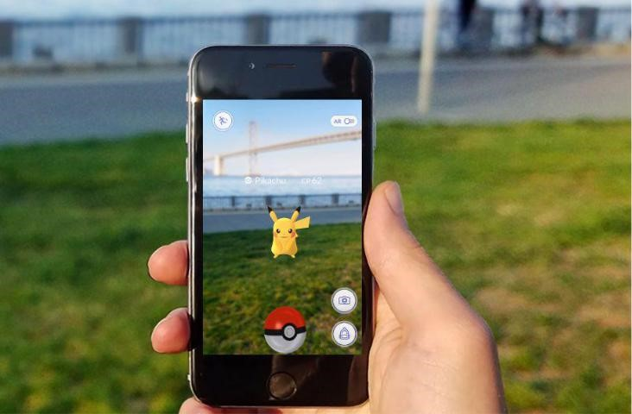

Figure 1.2 Pokémon Go with AR technology

### Problem Statement

Resume is an important tool to present one’s background and skillsets when it comes to job application. However, problems arise when job applicants want to write an ideal resume that stands out. One of the problems is the lack of experience of fresh graduates in building a resume. Most of them tend to make mistakes in building a resume (Mustafa, 2018) and end up producing a poorly-formatted unprofessional resume, which might not be catching employer’s eye.

Besides, job applicants who have numerous achievements and certifications would want to attempt the “one-size-fits-all” approach (Vogt, n.d.) that will cause a lengthy resume. An ideal resume is about one or two pages long and consists of three key elements like working experience, measurable achievements and educational background or professional training (Mustafa, 2018). Hence, it does not allow them to attach as many achievements, certifications and other important attachments as they possibly have.

Another problem is building a resume is the tedious work being laboured in it as it includes the processes of drafting, formatting and writing (Copeland, n.d.). A few ways of building a resume according to one’s preference are using existing online resume generator and also using any word processors.

### Aim and Objectives

The aim for the project is to develop a resume generator that allows job seekers to create a resume online and an AR technology as a supplement to the resume. Augmented digital elements such as videos, images and documents can be viewed in the resume through a camera of any mobile devices.

The objectives of this project are:

1. To study a comparative analysis of the existing online resume generators.
2. To develop a web-based application to generate an augmented reality resume as an interactive medium in job application and interviews.
3. To test the resume across various kinds of mobile devices.

### Scope

The target audience of this project is the job seekers. The project will be focused on the development of the resume generator website that produces an augmented reality resume to be viewed across different mobile devices.

Here will be the flow of the project:

1. Create an account and sign in the online resume generator application.
2. Create a blank resume of any one of the templates or themes.
3. Provide inputs about one’s personal details such as educational background, contact information and the like.
4. Upload any attachments of any kinds of multimedia elements such as audio, videos, pictures and documents.
5. Save, preview and download the final resume as PDF.
6. Scan the generated resume with any mobile devices with camera.

When scanning the resume, it will display 2D computer-generated perceptual information in the form of interactive digital elements and is able to play videos and audios as well as to view documents and pictures. To use the entire application, mobile devices, camera and Internet connection are required.

In this project, Ar.js and A-Frame will be the tools to do web augmented reality which are compatible in any web browsers regardless of the operating system. React.js will be used a frontend web framework while Node.js will be the backend web framework. MySQL will be the database application to store the information.

### Significance of the Project/Research

The project is to expect to enable the job seekers to create a resume easily and conveniently because a template of resume is prepared for them without the need to go through the processes of drafting and writing a resume. It is also to expect that they can view the digital media elements as augmented features in the resume through the camera.

### Organization of Thesis

The organization of the thesis are as follow.

1. Chapter 1: Introduction

To discuss about the background of resume and augmented reality. Besides, this section also provides a brief understanding about how the project will be developed and how AR is introduced in this project. It also explains the aim and objectives, scope and the significance of the project.

1. Chapter 2: Literature Review

To analyse and study the main components of this project such as resume, existing online resume generators and AR technology in more details. This section also includes the comparative study of the online generators.

1. Chapter 3: Methodology

To explain the selected methodology in this project. It is broken down into phases to discuss the actions to be done during the project development.

1. Chapter 4: Implementation of Design

To present the design of the overall project through diagrams and graphical user interface (GUI). Development frameworks to be used will be discussed in this section.

1. Chapter 5: Conclusion

To conclude the overall project and explain the expected outcome for FYP 2.

## LITERATURE REVIEW

### Introduction

This chapter analyses and studies the main components of this project about some subject matters such as resume, existing online resume generators and AR technology in more details. A comparative study among existing similar applications is carried out as well.

### Resume

Before diving into the details about resume, it is important to understand the differences between resume and curriculum vitae (CV). A CV is a detailed chronological overview of one’s education and professional history that usually has two or more pages compared to resume that has fewer sections, providing a snapshot of how job applicants’ skills and experiences align with employer’s needs, and the preferred length is one page. Besides, the contents of the resume are more dynamic as they can be selective about the contents and update them. CV’s contents are more static and it evolves (Kurtuy, n.d.). This project is intended for those who want to create a brief yet impressive summary about themselves as a marketing tool to the particular companies. Hence, resume is chosen to be the focus of this project.

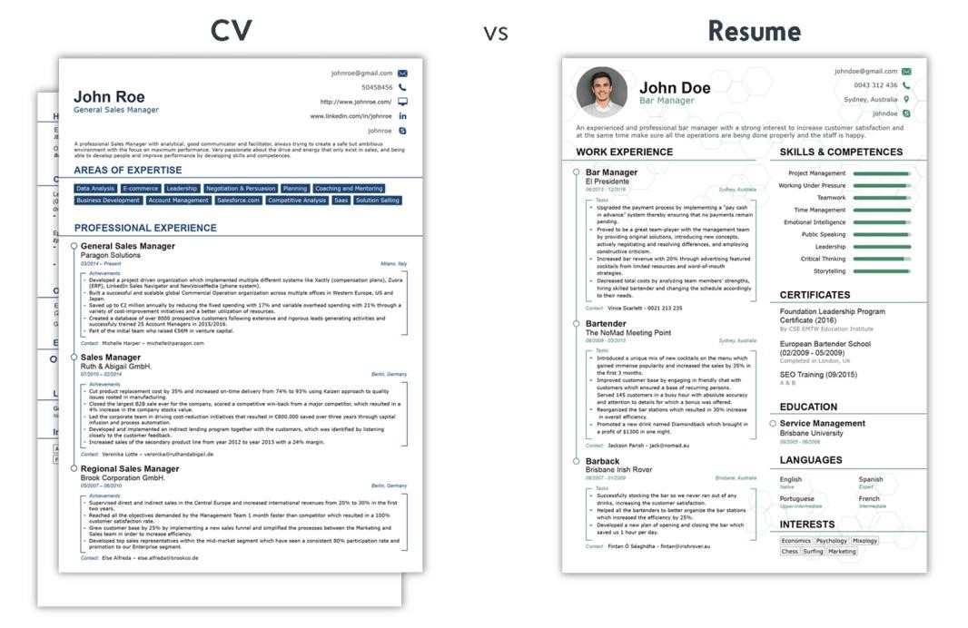

Figure 2.1 Differences between CV and Resume

#### Types of Resume

With regards to getting a job, there are a few types of resume. The table below shows the differences between them.

|  |  |
| --- | --- |
|  | Overview |
| Chronological | Focuses on working history from the past till present, in reverse order. It also focuses on skills if needed. However, this type of resume is not suitable for those who have lack of working experiences and huge employment gap. |
| Functional | Emphasizes on skills and strengths that are important to the employers. It de-emphasizes the working history. However, this type of resume is not preferred by employers as it makes them to have a negative impression on the job applicants that try to hide their employment gaps or lack of experience. |
| Combination | Blends the flexibility and strength of both types of resume (chronological and functional). It shows off a strong employment record with upward mobility. Besides, it shows off how they use their skills in the past to apply for their next job. However, it is not the focus of the resume and typically does not take up much space. This type of resume is suitable for those who plan for a career change. |
| Targeted | It is highly focused on a particular job. It means to apply for different jobs, job applicants have to create separate resumes for different career paths. It is brief and easy to read. |
| Infographic | Instead of text, graphic design elements are used to display one’s skills, qualifications, work experience and the like. Layout, colours, design, formatting, icons and font styling are the design elements to organize content. |
| Resume with profile | Supplements a profile section in the resume. One can provide a concise summary about their skills, experiences and goals that are relatable with the job they apply for. It is a way to “sell” themselves to the particular company. |
| Non-traditional | May include photos, graphics, images, other visuals and even videos. It might also be an online resume and act as a resume on social networking sites. It is ideal for people who are active in creative fields such as journalism and web design. |
| Mini | It is more than just a business card. It displays a brief summary of applicant’s career highlights and qualifications, only for the job that they want to apply for. It is useful at job fairs and career networking events. |

Table 2.1 Description of each type of resume (Types of Resumes, n.d.), (Doyle, 2019)

Among these types of resume, targeted resume is suggested to be used when applying jobs. It will be easier for employers to easily see and understand the relevance of one’s skills and experience to the particular job they apply for. It is well worth to put effort in this type of resume, especially when applying for job that is a good match with their experience and qualifications (Doyle, 2019). This type of resume allows them to update either adding or omitting as well as to customize it for the sake of satisfying the company’s job requirements.

#### Key Components of a Resume

A typical resume consists of some basic components, which are the header, summary statement, key skills and technologies, work experience and education. These are the parts that employers will expect to see regardless of what jobs the applicants are applying for.

|  |  |
| --- | --- |
| Key Components | Description |
| Header | The most crucial resume section. It contains name, contact information, address, phone number and email address. These are what the recruiters need to reach out to the applicants. Relevant website or LinkedIn URL can be included. |
| Summary statement | It follows the header and provides a short yet compelling description about career accomplishments and future ambitions. One can state the reason why they are the most qualified candidate for the job, highlight their most relevant skills and core competencies and the like. It is most likely to grab the attention from the recruiters. |
| Key skills and technologies | One can include computer skills, software skills and language skills. However, they must customize the skills they have in this section to match with the job description. Both hard and soft skills can be included but soft skills are much more important to the employers nowadays. |
| Work experience | Starts off with the most recent position followed by the past ones in reverse chronological order. For each position, company name, job title and employment date are included. Volunteer or unpaid experiences can be qualified as work experiences. |
| Education | Provides brief details of the academic qualifications in reverse chronological order. This section is placed below header (at the top of the resume) if applicants are looking for their first jobs since they leave their educational institutions, but for those who have been working that plan for a career transition, this section is placed at the bottom of the resume. |

Table 2.2 Description of key components of a resume (Buj, n.d.)

To produce a great resume that may cause a higher chance of impressing a hiring manager or recruiter, it is important that the resume is structured in an organized manner. An organisable resume is to keep the font traditional, layout appealing and spacing consistent. It is to represent oneself professionally. Besides, seeking anyone to proofread the resume is crucial as well to ensure correct spelling and grammar. One also must list a professional-sounding email address and a phone number that is attached to a professional voicemail greeting.

In addition, subjective words such as “reliable” and “hardworking” must be left out of the resume. It is because when employers call applicants to attend an interview, they expect that applicants can solve a problem for them instead of them saying that they are reliable and hardworking. It is also vital to incorporate keywords listed in the job description into the resume. It will help to quicken the process of scanning the resume to see if the applicants are the perfect match. Brief explanation for employment gaps and layoffs must be given.

Moreover, one’s employment history is to be kept to 10-15 ears if the applicants have a substantial amount of industry-related experience. If the applicants are recent graduates, part-time jobs, internships, volunteer work, coursework, projects and even unpaid experience can be included in the resume. It is also vital to use the space of the resume effectively. It is always accompanied with a cover letter which contains the different content from the resume and matches with the job description. Applicants are to be expected to meet all the qualifications listed in the job description and include past experiences to reflect it (Owens, 2014).

### Augmented Reality

AR provides users with a sensory experience beyond reality by seamlessly integrating virtual contents with the real world. AR evolves historically from the year of 1996 till today that emerges the dedicated AR devices and powerful development kits as well as improves the performance of mobile devices and sensor integration and advances in computer vision (CV) technologies. AR has brought benefits to such fields like entertainment, advertisement, education, navigation and maintenance. Pokemon Go, a location-based AR game has been popular till now since its public release in 2016. Web AR is the latest technology nowadays and is gradually emerging as a promising direction for mobile AR.

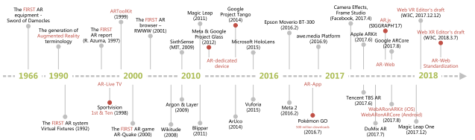

Figure 2.2 Historical evolution of AR

#### Mobile Augmented Reality

There are two dominant platforms for mobile Augmented Reality (mobile AR) for applications which are hardware-based and app-based. The current mobile AR hardware and operating systems that comprise of Embedded Linux, Android and iOS present a complex diversity. The advances in mobile devices, including computing and display platforms provide more choices for the implementation of AR applications.

Mobile AR has different implementation mechanisms with computing, networking and storage as the main complexities. The mechanisms are the sensor-based, vision-based and hybrid tracking methods. Sensor-based method is a lightweight approach where mobile devices support sensors like accelerometers, gyroscopes, compasses, magnetometers and GPS. The vision-based mechanism is where the camera provides the basis for vision based object recognition, detection and tracking which supports both marker-based and markerless methods. Marker-based method uses a predefined marker to meet the tracking requirement whereas markerless method detects and understands an unknown or outdoor real-world environment. It is currently using SLAM and collaborates it with other sensors to face the obstacle of computational inefficiency and limitations of the resources of mobile devices. Hybrid tracking mechanism combines different methods that increase the complexities of networking, storage and computational compared to the other mentioned mechanisms.

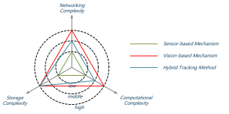

Figure 2.3 Computational/storage/networking complexities for the three typical implementation mechanisms

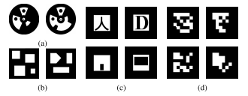

Figure 2.4 Marker-based methods

However, there are some downsides of mobile AR. The hardware-based implementation is costly and lacks of flexibility whereas the app-based requires additional downloading and installation. Most of its applications and solutions are designed based on a specific platform which causes the inconvenience for cross-platform deployment. To reach more users, an AR application needs to go through repeated development cycles to accommodate different platform which undoubtedly increases the cost of development and deployment.

#### Web Augmented Reality

The birth of web Augmented Reality (web AR) is known to be the future promising direction for mobile AR. It is because of its lightweight, native cross-platform features and pervasive service provisioning of mobile AR. Thanks to the invention of the World Wide Web (WWW), it makes the web AR possible. The idea of using web in the technology of AR is that the web simplifies the service access for users, for example Facebook and Snapchat which they are designed in a hybrid way (native + web) way that provides a good interaction experience and cross-platform support.

However, there are some challenges when AR meets the web in real life. Compared to mobile AR, web AR has the limited computing and rendering capability that causes the degradation of the performance of web AR. It also hinders the fiducial tracking method that provides an accurate and robust tracking approach for web AR applications. Markerless mobile AR implementation is to be ported to the web. Another challenge of web AR is network delay. When web AR application is deployed into the cloud server, there are large communication delays, due to the limited data rate and unacceptable network delay which causes the difficulty for current mobile networks to support real-time operations like tracking and interaction.

Besides, web AR is a power-hungry application which is due to limited battery capability. The need for the sensors to cooperate over a long period of time, the analysis of the information, computing, communication and display puts tremendous pressure on the battery of the mobile device. Hence, the extreme energy consumption hinders the deployment of web AR. In addition, diverse enabling infrastructures also cause a compatibility challenge in terms of display platforms, operating systems and data formats. Besides, it is also challenging the development of web AR when it comes to supporting different sensor, display platforms and OS. The virtual contents crated by different tools also causes compatibility issue.

Regardless of the issues mentioned, there are two approached solutions that can solve the issues. Both limited computing capability and limited battery capability can be solved by offloading computation-intensive tasks to the remote cloud. It will accelerate the performance for web AR applications. Since they are dependent on mobile networks, communication delays are caused by offloading computing tasks to the cloud. It happens when getting data from the cloud server. But it can be solved by the 5G network, the upcoming advanced network technology in the future that provides higher bandwidth (0.1 – 1 GB/s) and lower network delay (1 – 10 ms), which improves data transmission on mobile networks. However, the deployment of web AR applications into the cloud server requires high monetary cost.

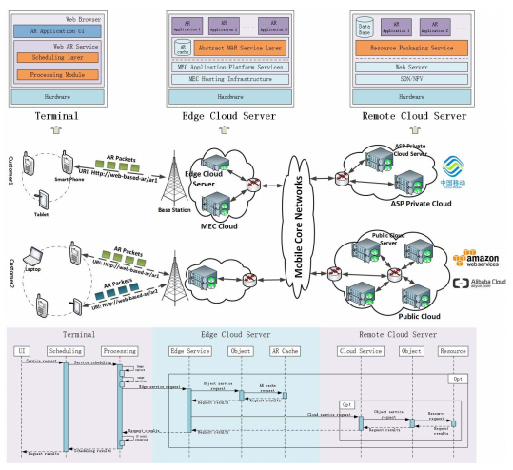

Figure 2.5 Overview of the framework for web AR with mobile edge computing (MEC)

##### Enabling Technologies for Web AR

There are some advanced web technologies emerging to meet the basic requirements of web AR as well as to improve performance. Such technologies are WebRTC, Web Assembly, Web Workers and WebGL.

WebRTC is one of the most important and basic technology that provides browsers with real-time communications. It allows the camera to capture the ambient environment in the form of a video stream as well as supports video coding, encryption, rendering and processing. Web Assembly is designed as a computational acceleration approach on the web by encoding procedures into a size-time-efficient and load-time-efficient binary format which can be executed on the web directly. It is to simplify the programming process and achieve native speed. It also solves the bottleneck problem of JavaScript and improves performance.

Web Workers utilizes worker threads to achieve parallelized computing, rendering, and resource loading in an asynchronous way. It provides a simple method for program parallelization of web AR applications, such as 3D model predownloading and parallelized feature points matching. It can provide users with a better experience, especially under the current mobile networks by scheduling and balancing the time and resource-consuming operations. WebGL provides a hardware-based (GPU) rendering acceleration approach on the web. It is important that it makes the presentation of AR smoother and more realistic on the web and it has a set of efficient JavaScript APIs for interactive 2D and 3D graphics rendering. Three.js is a WebGL-based JavaScript library.

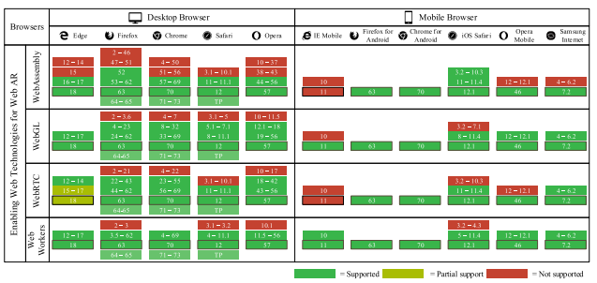

Figure 2.6 Browsers support tables of enabling web technologies

##### Different Web AR Implementation Approaches

There are two types of approaches in implementing web AR which are self-contained method and computation outsourcing.

In self-contained method, there are two types of approaches. The first one is to develop pure JavaScript-based libraries or plug-ins. AR.js is an examples of web AR solution based on Three.js and JSARToolKit5 that can work on all platforms and any browser with WebRTC and WebGL. Another example is Awe.js that is based on natural feature tracking (2D image). However, this method has an inefficiency of computing capability. The other approach is to extend the browser kernel. It enables the web AR applications to get near-native performance on mobile devices and thus a better user experience. It is powerful but it is still in their infancy and have not been applied in practice on a large scale.

Computational outsourcing method leverages the computation and storage capabilities of the cloud servers and provides a better user experience compared to the self-contained method. It has stronger computing capability of the servers and reduces the computing capability requirement. However, network issues happen since web AR is dependent on mobile network, especially when it comes to this method. The network issue can be optimized by the 5G network.

### Comparison Between Similar Existing Applications

#### NovoResume

NovoResume is a highly rated online resume generator. It has a few features and one of them is that it offers the ready-made professional templates such as functional, modern, simple, creative, basic, professional, college and executive. Besides resume templates, it also offers CV templates and cover letter templates.

## METHODOLOGY

### Subsection Title 1

Spacing between title of subsection and first line of text is 1.5 lines. The first paragraph in a subsection should align with left margin. General alignment for texts in paragraph should be “justified”.

Spacing between paragraphs is 1.5 lines. Subsequence paragraphs should be indented 1.27 cm (0.5 inch) from the left margin. General alignment for texts in paragraph should be “justified”. Spacing between last line of text and the next subsection title is 4.5 lines.

### Subsection Title 2

Spacing between title of subsection and first line of text is 1.5 lines. The first paragraph in a subsection should align with left margin. General alignment for texts in paragraph should be “justified”.

A new paragraph should not begin on the last line of a page. A subsection title should not begin on the last line of a page.

### Sub-subsection Title 1

#### Sub-sub-subsection Title 1

Spacing between title of subsection and first line of text is 1.5 lines. Spacing between the last line of text and table is 1.5 lines.

**Table 3.1: Processing Time (in hours) of Bread for Different Production Line**

|  |  |  |  |  |  |
| --- | --- | --- | --- | --- | --- |
| **Bread** | **Production Line** | | | | |
| **1** | **2** | **3** | **4** | **5** |
| **A** | 30 | 18 | 26 | 17 | 15 |
| **B** | 23 | 22 | 32 | 25 | 30 |
| **C** | 17 | 31 | 24 | 22 | 29 |

Spacing between the table and first line of text is 3.0 lines. Spacing between the last line of text and figure is 1.5 lines.

Source

Reflected

**Figure 3.1: Reflection from Smooth Surface**

Spacing between the figure and first line of text is 3.0 lines. Subsequence paragraphs should be indented 1.27 cm (0.5 inch) from the left margin.

## IMPLEMENTATION OF DESIGN

### Subsection Title 1

Spacing between title of subsection and first line of text is 1.5 lines. The first paragraph in a subsection should align with left margin. General alignment for texts in paragraph should be “justified” (Warner, 2002).

Spacing between paragraphs is 1.5 lines. Subsequence paragraphs should be indented 1.27 cm (0.5 inch) from the left margin. General alignment for texts in paragraph should be “justified”. Spacing between last line of text and the next subsection title is 4.5 lines.

### Subsection Title 2

Spacing between title of subsection and first line of text is 1.5 lines. The first paragraph in a subsection should align with left margin. General alignment for texts in paragraph should be “justified”.

A new paragraph should not begin on the last line of a page. A subsection title should not begin on the last line of a page. A new chapter must start on a new page.

### Sub-subsection Title 1

#### Sub-sub-subsection Title 1

Spacing between title of subsection and first line of text is 1.5 lines. The first paragraph in a subsection should align with left margin. Spacing between the last line of text and table is 1.5 lines.

**Table 4.1: Processing Time (in hours) of Bread for Different Production Line**

|  |  |  |  |  |  |
| --- | --- | --- | --- | --- | --- |
| **Bread** | **Production Line** | | | | |
| **1** | **2** | **3** | **4** | **5** |
| **A** | 30 | 18 | 26 | 17 | 15 |
| **B** | 23 | 22 | 32 | 25 | 30 |
| **C** | 17 | 31 | 24 | 22 | 29 |

Spacing between the table and first line of text is 3.0 lines. Spacing between the last line of text and figure is 1.5 lines.



**Figure 4.1: UNIMY Logo**

Spacing between the figure and first line of text is 3.0 lines. Subsequence paragraphs should be indented 1.27 cm (0.5 inch) from the left margin.

## CONCLUSION

### Subsection Title 1

Spacing between title of subsection and first line of text is 1.5 lines. The first paragraph in a subsection should align with left margin. General alignment for texts in paragraph should be “justified” (Warner, 2002).

Spacing between paragraphs is 1.5 lines. Subsequence paragraphs should be indented 1.27 cm (0.5 inch) from the left margin. General alignment for texts in paragraph should be “justified”. Spacing between last line of text and the next subsection title is 4.5 lines.

### Subsection Title 2

Spacing between title of subsection and first line of text is 1.5 lines. The first paragraph in a subsection should align with left margin. General alignment for texts in paragraph should be “justified”.

A new paragraph should not begin on the last line of a page. A subsection title should not begin on the last line of a page. A new chapter must start on a new page.

### Sub-subsection Title 1

#### Sub-sub-subsection Title 1

Spacing between title of subsection and first line of text is 1.5 lines. The first paragraph in a subsection should align with left margin. General alignment for texts in paragraph should be “justified”.

## REFERENCES

Bonsor, K., & Chandler, N. (n.d.). *How Augmented Reality Works*. Retrieved from howstuffworks: https://computer.howstuffworks.com/augmented-reality.htm

Buj, M. (n.d.). *Resume Sections You Must Include in Your Resume*. Retrieved from LiveCareer: https://www.livecareer.com/resources/resumes/basics/resume-components

Copeland, A. (n.d.). *6 Resume Writing Tips to Write a Stand-out Resume*. Retrieved from LiveCareer: https://www.livecareer.com/resources/resumes/how-to/write/how-to-make-resumes-easier

Doyle, A. (2019, July 11). *Different Resume Types*. Retrieved from thebalancecareers: https://www.thebalancecareers.com/resume-types-chronological-functional-combination-2063235

Heathfield, S. M. (2018, August 8). *Learn Why a Resume Is Important for an Employer*. Retrieved from thebalancecareers: https://www.thebalancecareers.com/resume-and-why-is-it-important-1918246

Kurtuy, A. (n.d.). *CV vs. Resume - What are the Differences & Definitions [+ Examples]*. Retrieved from Novoresume: https://novoresume.com/career-blog/cv-vs-resume-what-is-the-difference

Mustafa, Z. (2018, November 7). *Writing a resume: Art of your ownself*. Retrieved from New Straits Time: https://www.nst.com.my/education/2018/11/429011/writing-resume-art-your-ownself

Owens, P. (2014, January 23). *The 10 Key Components Of A Great Resume*. Retrieved from Work It Daily: https://www.workitdaily.com/resume-key-components-great

*Resume*. (n.d.). Retrieved from Ginger: https://www.gingersoftware.com/content/writing-center/resume/

Roo, J. (2015, April 27). *The Importance of a Well Written Professional Resume | Roo Resumes*. Retrieved from LinkedIn: https://www.linkedin.com/pulse/importance-well-written-professional-resume-roo-resumes-judi-roo/

*Types of Resumes*. (n.d.). Retrieved from Minnesota State Careerwise: https://careerwise.minnstate.edu/jobs/resumecharts.html

Vogt, P. (n.d.). *The 10 worst resume mistakes to avoid*. Retrieved from Monster: https://www.monster.com/career-advice/article/avoid-the-top-10-resume-mistakes

*What is Augmented Reality (AR) and How does it work*. (n.d.). Retrieved from ThinkMobiles: https://thinkmobiles.com/blog/what-is-augmented-reality/

## APPENDICES

APPENDIX A: Graphs

Spacing between chapter title and first line of text is 4.5 lines. The first paragraph in a subsection should align with left margin. General alignment for texts in paragraph should be “justified”.

Spacing between paragraphs is 1.5 lines. Subsequence paragraphs should be indented 1.27 cm (0.5 inch) from the left margin. General alignment for texts in paragraph should be “justified”.

APPENDIX B: Computer Programme Listing

Spacing between chapter title and first line of text is 4.5 lines. The first paragraph in a subsection should align with left margin. General alignment for texts in paragraph should be “justified”.

Spacing between paragraphs is 1.5 lines. Subsequence paragraphs should be indented 1.27 cm (0.5 inch) from the left margin. General alignment for texts in paragraph should be “justified”.